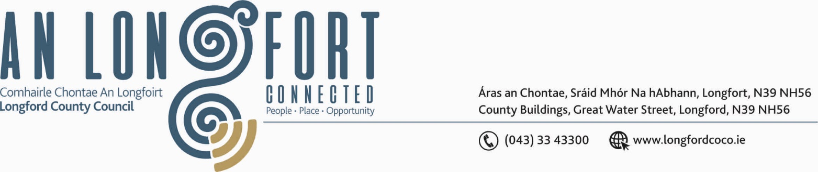

GRANARD MUNICIPAL DISTRICT

Corporate Affairs,
Aras an Chontae,
LONGFOIRT.
Please note date and time of meeting.
28th November 2019.

To: Each Member of Granard Municipal District.

Dear Member,

You are requested to attend Meeting of Granard Municipal District to be held in
Granard Community Library on Wednesday 4th December 2019 at 4.00 p.m. to transact business, as set out on the Agenda hereunder.

Yours sincerely,
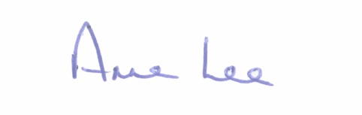

_______________
Anne Lee,
Meetings Administrator.

AGENDA

Prayer before meeting.

1. Confirmation of Minutes of Municipal District Meetings held on the
24th September and 22nd October 2019 - copy enclosed

2. Matters arising from Minutes.

3. Declaration of Interest by Members.

4. Area Engineer’s Progress Report.

5. Update on Granard Public Art Features.

6. Notices of Motions, submitted by Councillors, as listed hereunder –

Councillor Turlough McGovern.

“I request that signs be placed at Wheelchair Parking Bays stating ‘Permit Holder Only Wheelchair Parking” as these parking bays are being used and abused as regular parking bays.”

“I request an update on parking arrangements in Granard. Parking, in general in Granard, is getting to a crisis point and needs to be addressed for the benefit of the people of Granard”

Councillor Paraic Brady.

“That Longford County Council cleans our signage along our roads and junctions as some of it is hidden with vegetation and covered in dirt.”

“What is the update on repair to the bridge in Ballinamuck.”

Councillor Michael Carrigy.

“I call on the OPW to provide funding to carry out a feasibility study on all small rivers, tributaries etc with regard to developing a scheme similar to the LIS to alleviate flooding issues.”

7. A.O.B.



